Prof. N.R. Kamath Memorial Quiz - ChEQ 2020

The morning of 7th March witnessed anxious students from ten colleges under IIChE MRC viz. Mahatma Gandhi Memorial College of Engineering, Indian Institute of Technology Bombay, Finolex Academy of Management and Technology, Bharti Vidyapeeth College of Engineering, Thadomal Shahani College of Engineering, Gharda Institute of Technology, Shivajirao Jondhale College of Engineering, Datta Meghe College of Engineering, Institute of Chemical Technology and D. J. Sanghvi College of Engineering assembling at the seminar hall of D. J. Sanghvi College of Engineering for ChEQ 2020. As the participants settled down, Dr. Aparna Tamaskar made the opening remarks by giving a brief introduction about the highly coveted “N. R. Kamath Quiz” and welcoming the decorated dignitaries. The guests for the event included veterans from the industry and executive council members of IIChE like Mr. Mahendra Patel, Mr. Praveen Saxena, Dr. Sanjay Mahajani, Dr. Sujit Jogwar and Dr. Sunil Bhagwat. The event then proceeded with the guests lighting the lamp along with Principal, Dr. Hari Vasudevan, Head of the Chemical Department, Dr. (Mrs.) Alpana Mahapatra and other professors. The quiz started on an auspicious note with the national anthem and “Saraswati Vandana”.
After the inauguration ceremony, the participants were apprised of the rules for the rounds and the entire event in general. Dr Sunil S. Bhagwat was the quiz master for round one. The first round comprised of two slots of five teams each. Each slot was further divided into two sub-rounds, one of which was a buzzer round and the other where separate questions were asked to separate teams. This round concluded with a tiebreaker between four teams which were Thadomal Shahani College of Engineering, Indian Institute of Technology Bombay, Mahatma Gandhi Memorial College of Engineering and Gharda Institute of Technology.
This was immediately followed by the round two of the event wherein there were six sub-rounds. The quiz master for this round was Dr. Sujit Jogwar from IIT-B. The top six teams from first round were the competitors for the second. The format of the second round was same as the first. The fourth sub round was followed by lunch.
The post lunch session witnessed the second tiebreaker for the day. This time, D. J. Sanghvi College of Engineering and Bharti Vidyapeeth College of Engineering were in the fray for proceeding to round three. D. J. Sanghvi College of Engineering gave a tough fight but were eliminated and the latter went ahead.
The third and final round which was hosted by Dr. Sanjay Mahajani witnessed a fierce competition between the three remaining teams viz. IIT-B, ICT and Bharti Vidyapeeth College of Engineering. This was a rapid-fire round with each team getting 90 seconds to answer the maximum number of questions. As the round culminated and the counting of scores was in progress, there was a deafening silence in the hall. Soon the winners were declared. Students from Indian Institute of Technology Bombay emerged victorious followed by Institute of Chemical Technology and Bharti Vidyapeeth College of Engineering in the third place.
The valedictory ceremony then ensued and a tabla session added melodious musical notes to the seminar hall. The dignitaries present on the dais included, Dr. Hari Vasudevan, Dr. Ashish Daptadar, Dr. Alpana Mahapatra, Dr. Aparna Tamaskar, Dr. Sanjay Mahajani (Guest of Honor), Mr. Praveen Saxena. The participants then received their participation certificates and the three finalists were awarded with their certificate of merit along with cash prizes. The trophy was handed over to the victors and the dignitaries enlightened the audience with their wisdom. Dr. Aparna Tamaskar gave a vote of thanks as the convener of the event. Lastly, the dignitaries were felicitated by Dr. Hari Vasudevan and Dr. (Mrs.) Alpana Mahapatra and the event concluded with the national anthem.
D.J. Sanghvi College of Engineering took the onus of hosting the venerable quiz this year, setting new benchmarks about the same and has passed baton to the next host to take this quiz to new heights. The DJSCE IIChE student chapter is very grateful to the sponsors, CPE, KP Ltd., Genesis Membrane Sep Pvt Ltd., Dipesh Engineering Works, HEM Incense, Rio Ltd, because of which the event was possible.
PHOTO GALLERY

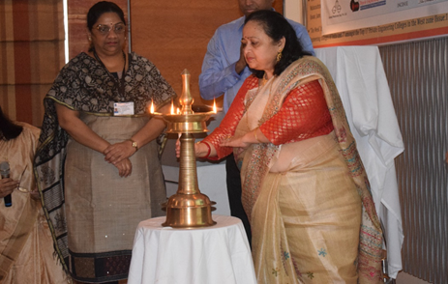
Dr. (Mrs.) Alpana Mahapatra, HOD chemical department; lighting the lamp
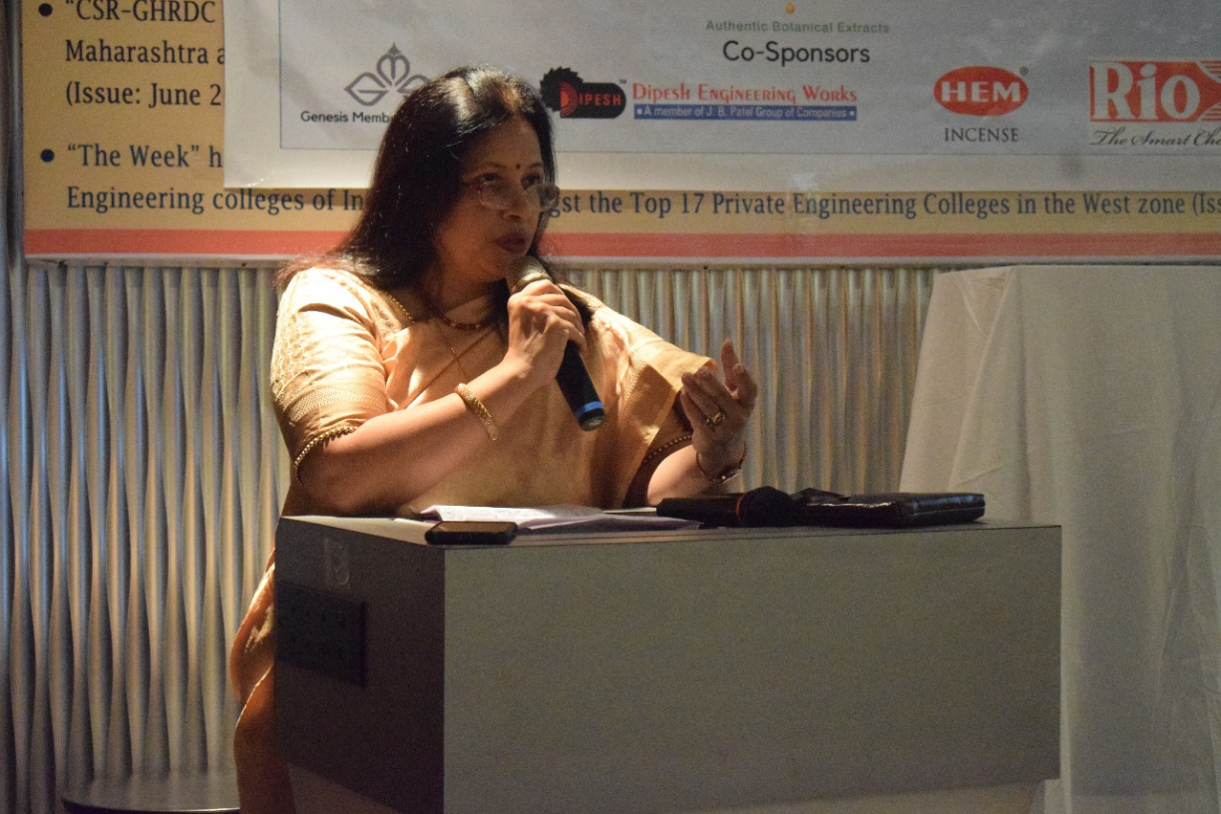
Dr. Aparna Tamaskar, Convener-ChEQ 2020 making the opening remarks
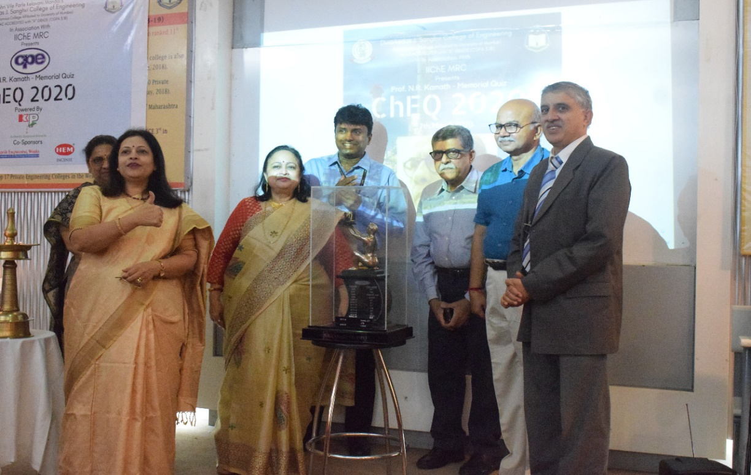
Unveiling of the ChEQ-2020 trophy
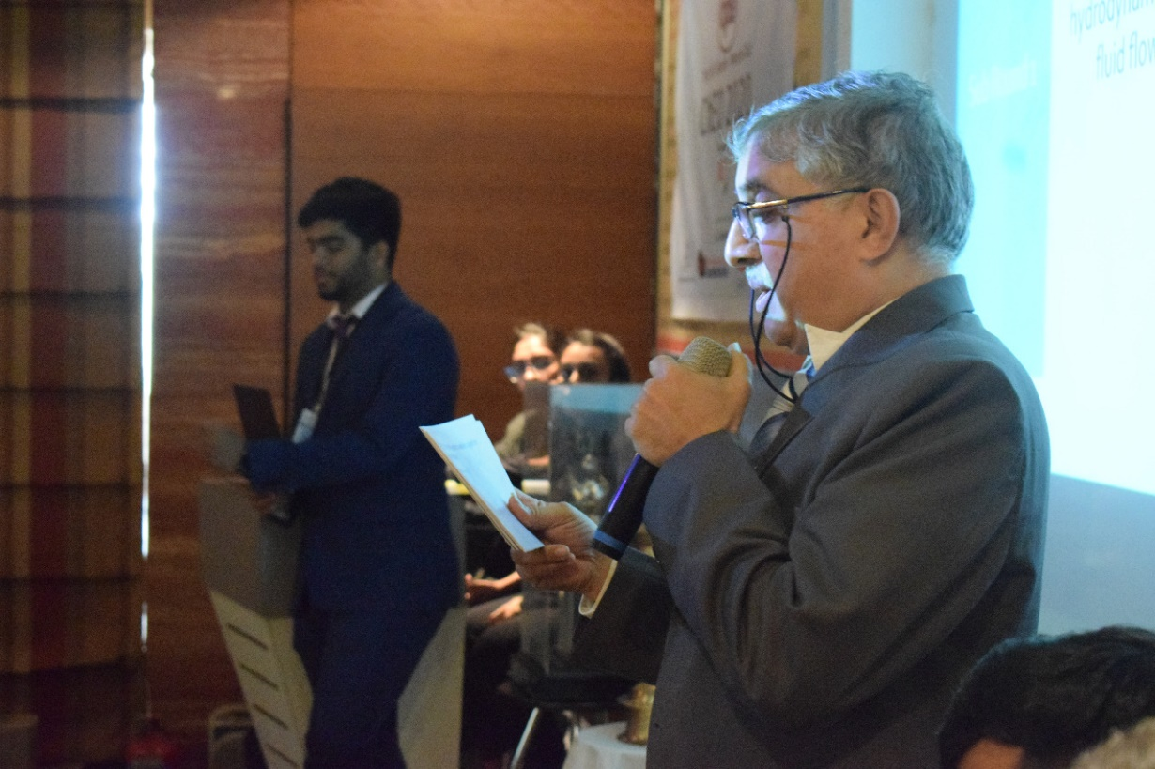
Dr. Sunil Bhagwat conducting the quiz

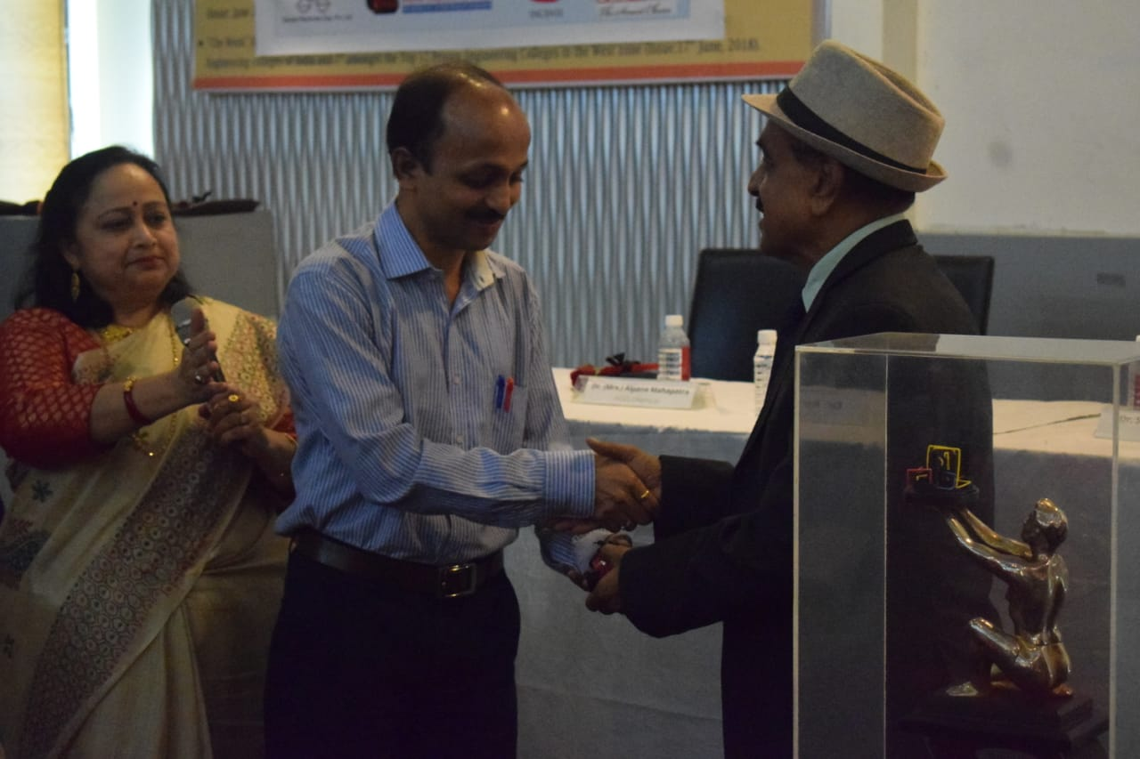

Dr. Ajitkumar Gudekar, coordinator-ChEQ 2020 felicitating Mr. Praveen Saxena

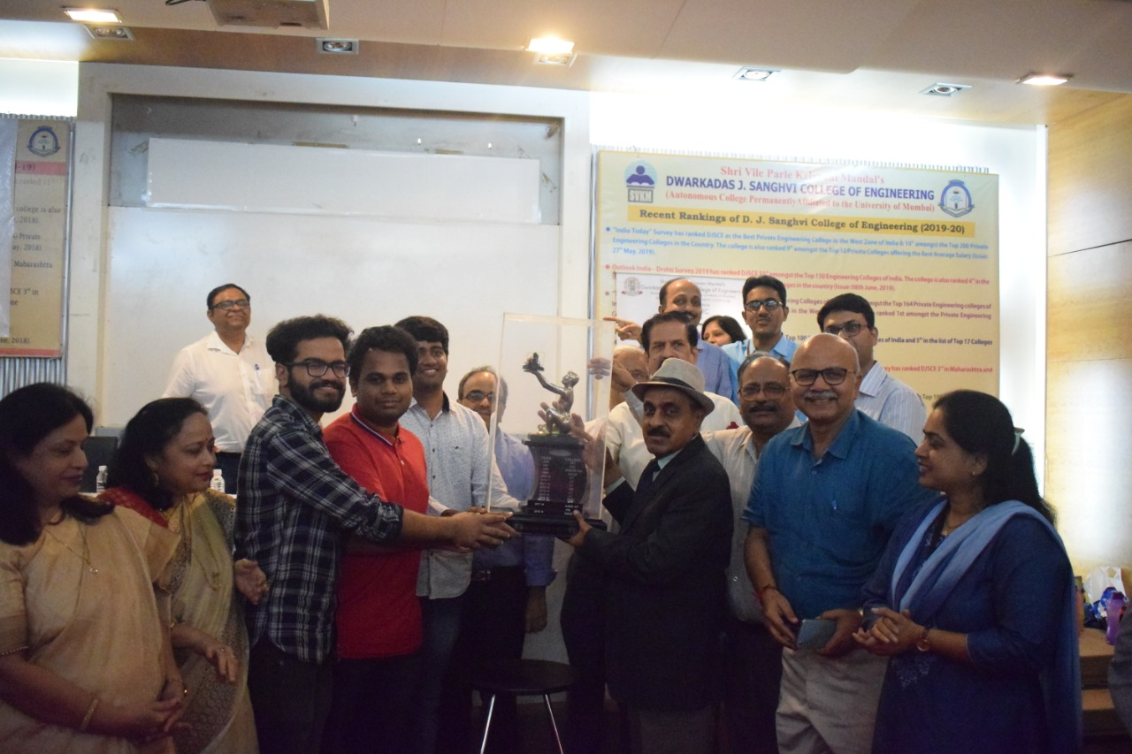
The winning team- IIT Bombay being presented with the ChEQ-2020 trophy

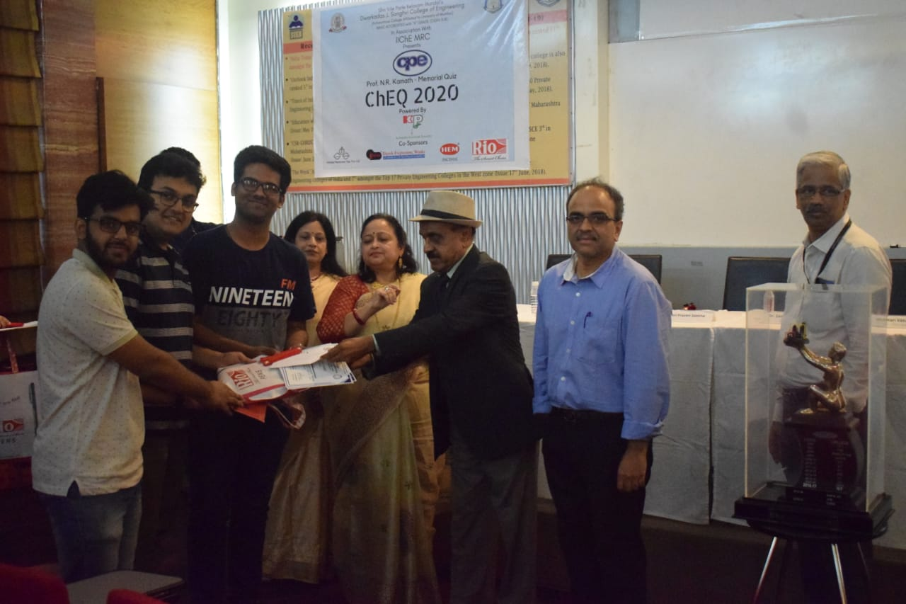
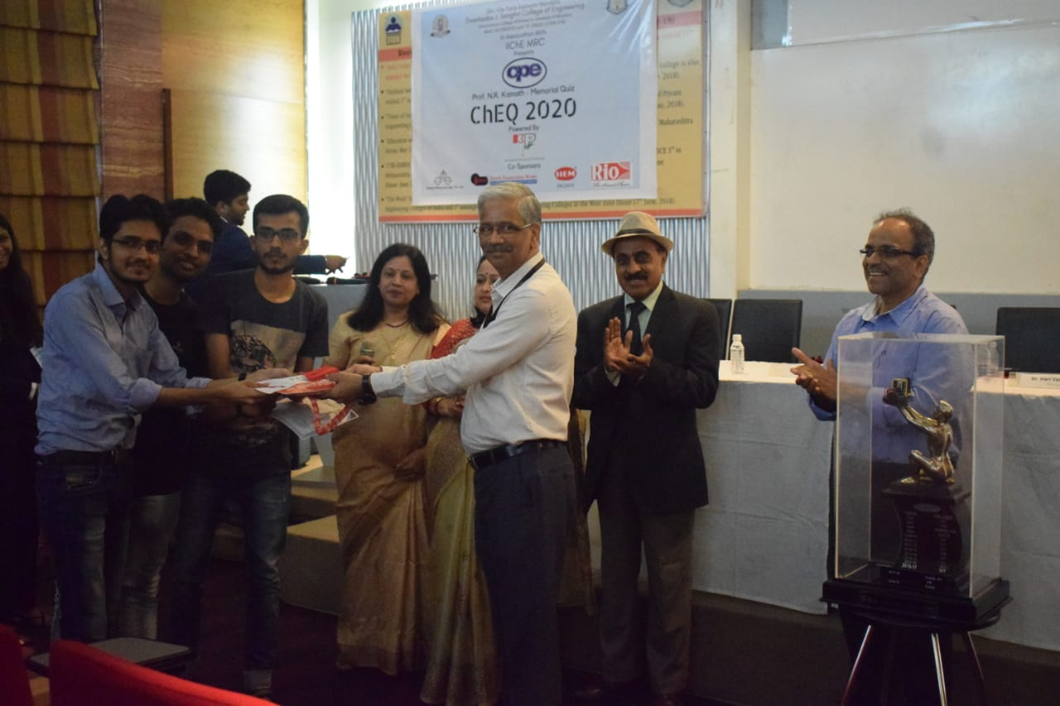
The first runner-up, Institute of Chemical Technology being presented with the cash prize

The second runner-up, Bharti Vidyapeeth College of Engineering being presented their award
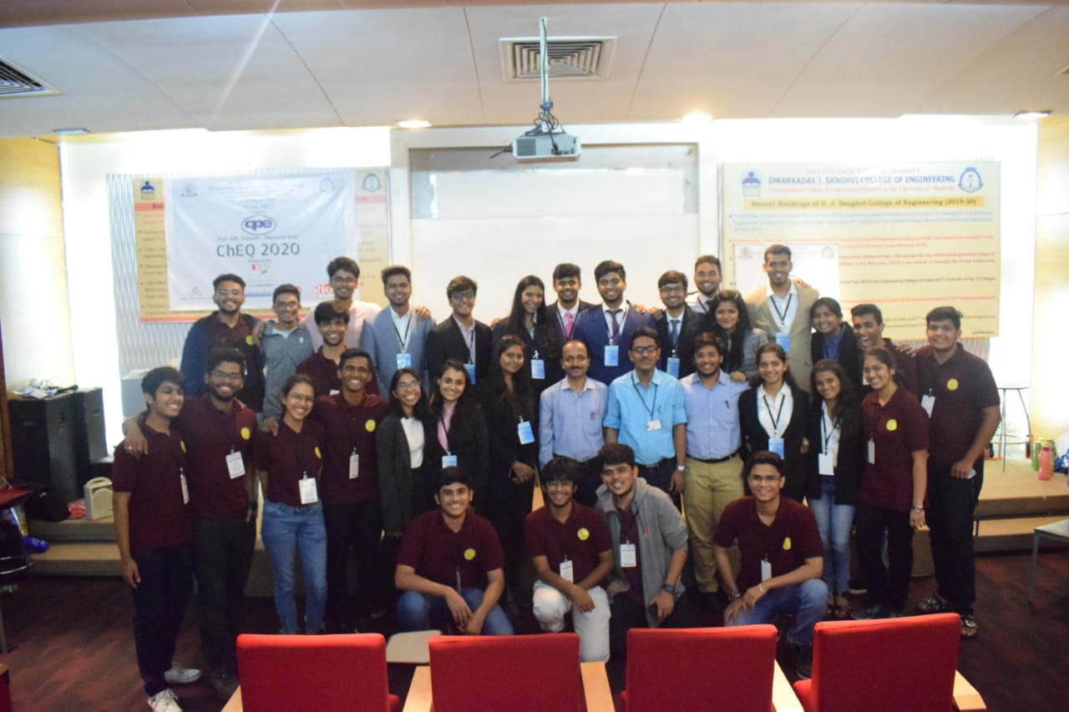

DJSCE IIChE student chapter after the event

